**Software Requirement Specification (SRS)**

Of

**HRMS Module**

**Employee Life Cycle**

**&**

**Appraisal**

For Implementation of

**Campus Management Software**

at

**World Skill Center (WSC)**

**Sustainable Outreach And Universal**

**Leadership (SOUL) Limited**

**Content**

A. Abstract 3

B. Introduction 3

C. Definition, Acronyms and Abbreviations 3

D. Overview of the Document 3

E. Scope of HRMS Module 4

F. List of Screens and their descriptions 4

G. Process Definition and Requirements 6

1. Employee Life Cycle 6

1.1 Grievance Type 8

1.2 Employee On-boarding 9

1.3 Employee On boarding Template 12

1.4 Employee Skill Map 14

1.5 Employee Promotion 16

1.6 Employee Transfer 17

1.7 Employee Grievance 19

1.8 Employee Separation Template 22

1.9 Employee Separation 23

1.10 Employee Re-engagement 26

1.11 Staff Suggestion 28

1.12 Employee Resignation 30

1.13 Employee Profile Updation 32

1.14 Appraisal Template 35

1.15 Appraisal 36

# Abstract

Software Requirements Gathering is one of the first phases of system development. This phase results in the Software Requirements Specification (SRS) document, which must contain a complete, concise, high-quality description of the system being considered.

# Introduction

The World Skill Center (WSC) is a premier advanced skill training institute established by the Government of Odisha, Skill Development and Technical Education Department, through the Odisha Skill Development Authority (OSDA). The WSC will impart advanced skill training in eight trades from engineering and service sectors. WSC caters primarily to induct the best talent from ITIs and Polytechnics and train them to become globally employable in emerging areas such as "Industry 4.0". WSC is housed in a state-of-the-art, 18-storey, air-conditioned building with nearly half a million square feet of space in the heart of capital city of Bhubaneswar.

With the Implementation of campus management software for WSC the goal is to streamline the operations and functions of the campus by integrating various processes, such as admissions, course registration, academic progress tracking, and financial management, HRMS, Procurement and Inventory management, etc into a unified system. The implementation also aims at providing a user-friendly interface for all stakeholders, making it easier for them to access the necessary information and complete their tasks with ease. The modules to be covered during the implementation of the software includes:

|  |  |
| --- | --- |
| Students Management Modules | Infrastructure Management |
| Academic System | Finance and Accounting System |
| Procurement & Inventory Management | Training and Placement |
| Human Resources Management System | Application Integration |

# Definition, Acronyms and Abbreviations

The following table explains the terms and abbreviations used in the document:

|  |  |
| --- | --- |
| **Abbreviation** | **Description** |
| SRS | Software Requirements Specification |
| HRMS | Human Resource Management System |
| R | Rename - When a field is Renamed |
| N | New - When a New field is Added |
| D | Delete - When an Existing field is Deleted |
| NA | Not Applicable |

# Overview of the Document

This requirement document provides a detailed overview of the functional requirements of a project. It serves as a communication tool between stakeholders, including developers, project managers, and end-users. The purpose of this requirement document is to define and document the project's objectives, scope, and expectations, and to ensure that all stakeholders have a clear understanding of what the project entails.

This document covers all the functional requirements of the **Human Resource Management System** of ERP Product. This module helps in organizing the entire HRMS set-up,manage recruitment process,employee life-cycle from on-boarding to employee separation,manages leaves and attendance of employees as well as Performance/Appraisal of employee.

# Scope of HRMS Module

* Recruitment process management
* Employee Life cycle including Employee boarding,promotion,transfer,retirements,separation and re-engagement of employee.
* Staff profile management including Educational qualification,work experience,work history and so on.
* Attendance Management
* Grievance and Disciplinary cases monitoring.
* Performance Management System.
* Leave management
* Shift Management

Following functionalities are covered in this SRS document:

* **Employee Life cycle (including Employee On-boarding,Employee Re-engagement,Employee Promotion and Transfer,Appraisal , Employee Grievance and Employee Suggestion) ** ▪

# List of Screens and their descriptions

The following screens are present in Employee Life Cycle sub module :

|  |  |  |
| --- | --- | --- |
| **Sl no** | **Existing Application** **Screen Name** | **Description** |
| Employee Life Cycle | | |
| 1 | Employee On-boarding | This feature helps you to maintain the masters of these activities, and create a set of tasks at the time of each Employee hiring.  . |
| 2 | Employee On boarding Template | The Employee On boarding Template is a blueprint which contains a predefined list of Activities for Employee On boarding. An Employee On boarding Template can be created for a particular Department, Designation and Employee Grade. |
| 3 | Employee Skill Map | Employee Skill Map is a record which helps your organization track your Employee's skill sets and training. |
| 4 | Employee Promotion | Promotion or career advancement is a process through which an Employee of a company is given a higher share of duties, a higher pay-scale or both Enroll button. |
| 5 | Employee Transfer | Employee Transfer is a form of internal mobility, in which the Employee is shifted from one job to another usually at a different location, department, or unit. |
| 6 | Employee Grievance | The employees of an organization can raise grievances and after investigation actions like pay cut and suspension can be taken and recorded. |
| 7 | Employee Separation Template | The Employee Separation Template is a blueprint which contains a predefined list of Activities for Employee Separation. |
| 8 | Employee Separation | Employee Separation is a situation when the service agreement of an Employee with his/her organization comes to an end and the Employee leaves the organization. |
| 9 | Employee Re-engagement | This form will be used for employees to apply for re-engagement in the job. |
| 10 | Staff Suggestion | This screen will help all the staffs to suggest something for the development of company policy . |
| 11 | Employee Resignation | A resignation form is a form that gives notice to an entity or organization of an employee's intent to quit their job. |
| 12 | Appraisal Template | User can manage Employee Appraisals by creating an Appraisal Template for each role with the parameters that define the performance by giving appropriate weightage to each parameter. |
| 13 | Appraisal | A performance appraisal is a method by which the job performance of an employee is documented and evaluated. |

# Process Definition and Requirements

## Employee Life Cycle

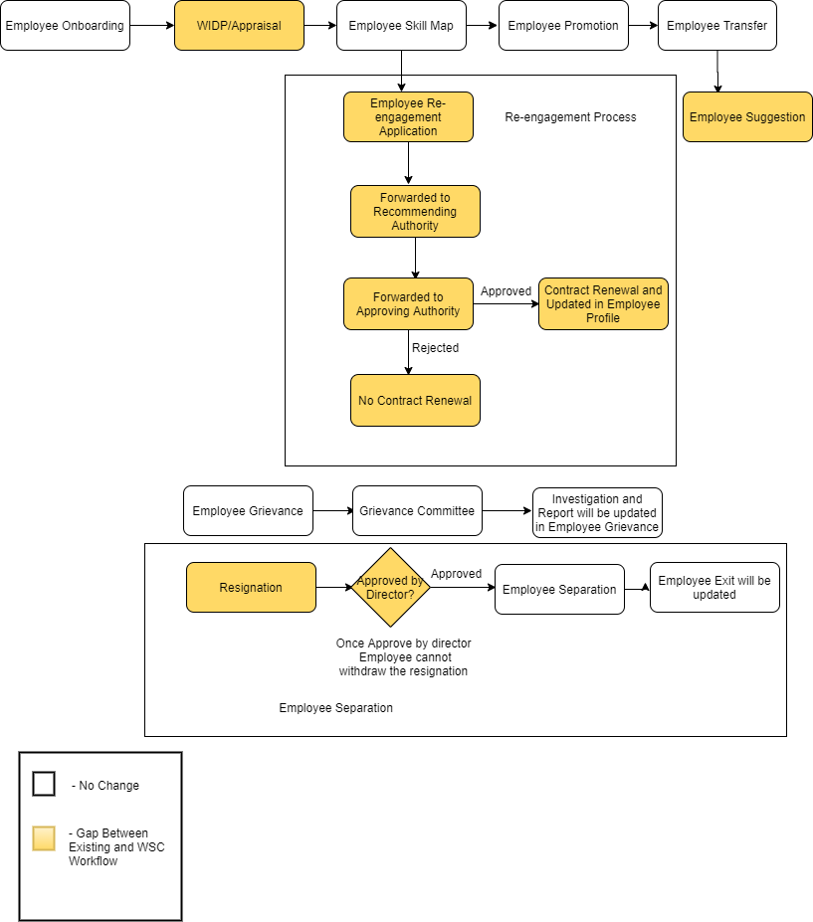

Figure 1 : Employee Life Cycle Workflow

**Description:**

**Masters**

The Employee Life cycle sub module needs the following master data.

* Employee
* Department
* Employment Type
* Designation
* Employee Grade
* Company
* Grievance Type
* Designation

(For Masters please follow WSC_SRS_HRMS_Masters document)

**Employee On-boarding**

In the process of hiring an Employee, there are set of standard activities which need to be executed. This feature helps you to maintain the masters of these activities, and create a set of tasks at the time of each Employee hiring.

**Employee On-boarding Template**

The Employee On boarding Template is a blueprint which contains a predefined list of Activities for Employee On boarding.

**Employee Skill Map**

Employee Skill Map is a record which helps your organization track your Employee's skill sets and training. It can be used to rate each skill of the Employee and track their growth after each internal training. This data can be used at the time of appraisals.

**Employee Promotion**

User can manage Employee Promotion and its various associated activities using this screen.

**Employee Transfer**

Employee Transfer is a form of internal mobility, in which the Employee is shifted from one job to another usually at a different location, department, or unit.

**Employee Grievance**

The employees of an organization can raise grievances and after investigation actions like pay cut and suspension can be taken and recorded.

**Employee Separation Template**

The Employee Separation Template is a blueprint which contains a predefined list of Activities for Employee Separation. An Employee Separation Template can be created for a particular Department, Designation and Employee Grade.

**Employee Separation**

Employee Separation is a situation when the service agreement of an Employee with his/her organization comes to an end and the Employee leaves the organization.Employee Separation is created for an Employee who has resigned or terminated from the organization.

**Employee Re-engagement**

An Employee will fill the application form once he will receive notification for re-engagement process.It will be then forwarded to Approving Authority.

**Staff Suggestion**

This screen will help all the staffs to suggest something for the development of company policy .

**Employee Resignation**

The objective of a resignation form, aside from informing the company of the employee's resignation, is to maintain a positive relationship between the two parties.

**Appraisal Template**

User can manage Employee Appraisals by creating an Appraisal Template for each role with the parameters that define the performance by giving appropriate weightage to each parameter

**Employee Appraisal**

The An appraisal form is a document that managers and human resources staff use to evaluate the performance of employees.

**Master Screens**

### Grievance Type

**General Description**

The following table describe overall information about this screen:

|  |  |
| --- | --- |
| **Description** | 1. Grievance Type consist of different kind of grievances like workplace harassment,work conditions. |
| **Navigation** | Home > HRMS > Employee Life cycle > Grievance Type |
| **Pre-requisites** | The system should have records in the following screen   1. Employee |
| **Existing Screen Name** | Grievance Type |
| **New Screen Name** | No change |

**Screenshot**

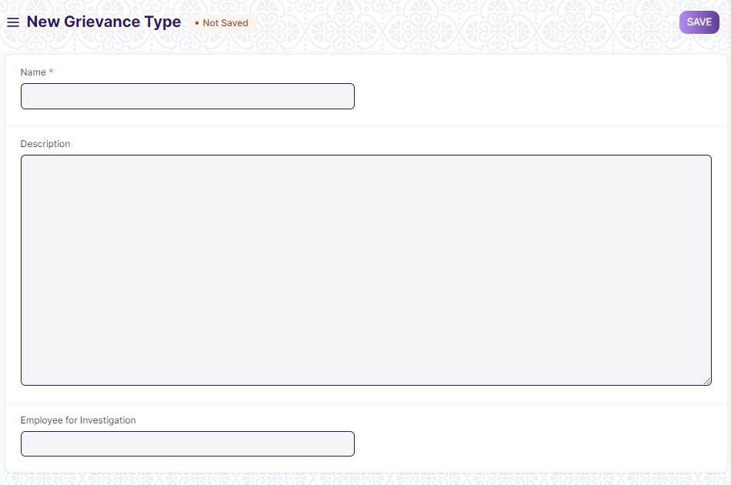

Figure 2 : Grievance Type Screen

**Field List**

The following table describes the UI fields present in this screen :

|  |  |  |  |  |  |  |
| --- | --- | --- | --- | --- | --- | --- |
| **ID** | **Label** | **Type** | **Mandatory** | **Validation / Action** | **Remarks** | **R= Rename**  **N= New**  **D= Delete** |
| 1 | Description | Text |  |  |  |  |
| 2 | Employee for Investigation | Link |  | Link to the master screen Employee |  |  |

**User: Roles & Permission**

The following table describes the users and their roles and permissions for the screens :

|  |  |  |  |  |  |  |  |  |  |
| --- | --- | --- | --- | --- | --- | --- | --- | --- | --- |
| **ID** | **Role** | **Select** | **Read** | **Write** | **Create** | **Delete** | **Submit** | **Cancel** | **Amend** |
| 1 | HR Admin/Director Admin | Yes | Yes | Yes | Yes | Yes | NA | NA | NA |
| 2 | HR Manager/CS | No | Yes | Yes | Yes | No | NA | NA | NA |
| 3 | HR Assistant | No | Yes | No | No | No | NA | NA | NA |
| 4 | Employee | No | Yes | No | No | No | NA | NA | NA |

**Transactional Screens**

### Employee On-boarding

**General Description**

The following table describes overall information about this screen:

|  |  |
| --- | --- |
| **Description** | 1. In the process of hiring an Employee, there are set of standard activities which need to be executed. 2. This feature helps you to maintain the masters of these activities, and create a set of tasks at the time of each Employee hiring. 3. Employee On-boarding is created for a Job Application, who is approved for the hiring. |
| **Navigation** | Home > HRMS > Employee Life Cycle> Employee On boarding |
| **Pre-requisites** | The system should have records in the following screen   1. Job Applicant 2. Employee 3. Department 4. Designation 5. Employee Grade |
| **Existing Screen Name** | Employee On-boarding |
| **New Screen Name** | No change |

**Screenshot**

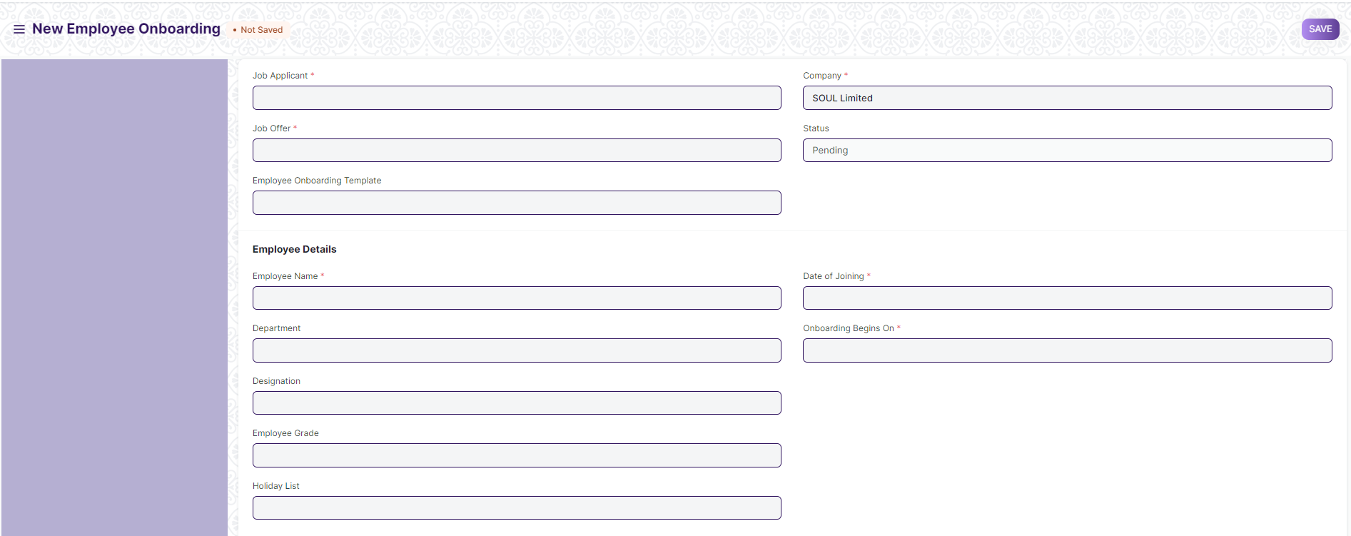

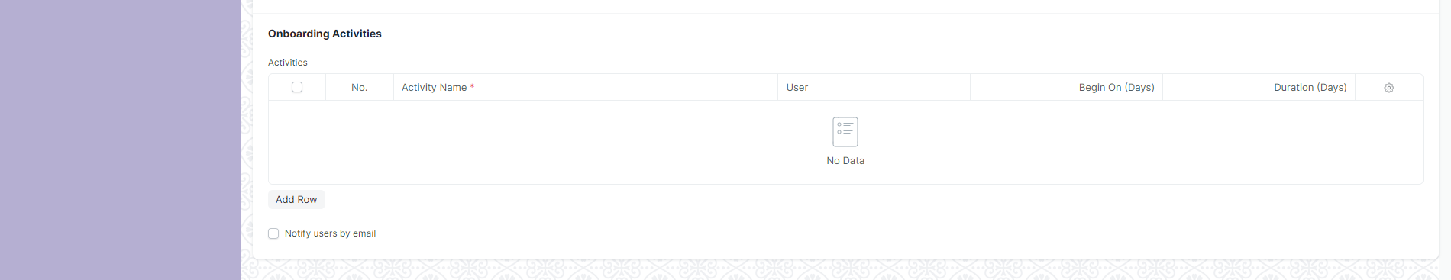

Figure 3: Employee On-boarding Screen

**Field List**

The following table describes the UI fields present in this screen :

|  |  |  |  |  |  |  |  |  |  |  |  |  |
| --- | --- | --- | --- | --- | --- | --- | --- | --- | --- | --- | --- | --- |
| **ID** | | **Label** | | **Type** | | **Mandatory** | | **Validation / Action** | | **Remarks** | | **R= Rename**  **N= New**  **D= Delete** |
| 1 | | Job Applicant | | Link | | Yes | | Link Field to the Job Applicant screen | |  | |  |
| 2 | | Job Offer | | Link | | Yes | | Link Field to the Job Offer Screen | |  | |  |
| 3 | | Employee On-boarding Template | | Link | |  | | Link Field to the Employee on-boarding template screen | | Employee On boarding template should be standardize | |  |
| 4 | | Company | | Link | |  | | Link Fields to Master Screen Company | |  | |  |
| 5 | | Status | | Checkbox | |  | | Options :  Pending  In Progress  Completed | |  | |  |
| 6 | | Project | | Link | | Yes | | Link Field to the project screen | |  | |  |
| 7 | | Employee | | Link | |  | | Link Field to the screen Employee | | Auto fetched on selecting Job Applicant | |  |
| 8 | | Employee Name | | Text | | Yes | |  | | Auto Fetched on selecting Job Applicant. | |  |
| 9 | | Department | | Link | |  | | Link Field to master screen Department | |  | |  |
| 10 | | Designation | | Link | |  | | Link Field to master screen Designation | |  | |  |
| 11 | | Employee Grade | | Link | |  | | Link Field to master screen Employee Grade | |  | |  |
| 12 | | Holiday List | | Link | |  | | Link Field to the Holiday List screen. | |  | |  |
| 13 | | Date of Joining | | Date | | Yes | |  | |  | |  |
| 14 | | On-boarding Begins On | | Date | | Yes | |  | |  | |  |
| 15 | | Activities | | Table | |  | |  | | The table is described below. | |  |
| 16 | | Notify users by email | | Checkbox | |  | | If checked , then a mail will be triggered to the employee. | |  | |  |
| **Employee Boarding Activity** | | | | | | | | | | | | | |
| **ID** | | **Label** | | **Type** | | **Mandatory** | | **Validation/ Action** | | **Remarks** | | **R = Rename**  **N= New**  **D= Delete** | |
| 1 | | Activity Name | | Text | | Yes | |  | |  | |  | |
| 2 | | User | | Link | |  | | Link Field to the User Screen | |  | |  | |
| 3 | | Begins On (Days) | | Number | |  | |  | |  | |  | |
| 4 | | Duration (Days) | | Number | |  | |  | |  | |  | |
| 5 | | Task | | Text | |  | |  | |  | |  | |
| 6 | | Status | | Drop down | | Yes | | Options :  Completed  Not Completed  Not Applicable | |  | | N | |

**User: Roles & Permission**

The following table describes the users and their roles and permissions for the screens :

|  |  |  |  |  |  |  |  |  |  |
| --- | --- | --- | --- | --- | --- | --- | --- | --- | --- |
| **ID** | **Role** | **Select** | **Read** | **Write** | **Create** | **Delete** | **Submit** | **Cancel** | **Amend** |
| 1 | HR Admin/Director Admin | Yes | Yes | Yes | Yes | Yes | Yes | Yes | Yes |
| 2 | HR Manager/CS | Yes | Yes | Yes | Yes | Yes | Yes | Yes | No |
| 3 | HR Assistant | No | Yes | Yes | Yes | No | Yes | No | No |
| 4 | Employee | No | Yes | Yes | No | No | No | No | No |

### Employee On boarding Template

**General Description**

The following table describes overall information about this screen:

|  |  |
| --- | --- |
| **Description** | 1. The Employee On boarding Template is a blueprint which contains a predefined list of Activities for Employee On boarding. An Employee On boarding Template can be created for a particular Department, Designation and Employee Grade. |
| **Navigation** | Home > HRMS > Employee Life cycle > Employee On boarding Template |
| **Pre-requisites** | The system should have records in the following screen   1. Department 2. Designation |
| **Existing Screen Name** | Employee On boarding Template |
| **New Screen Name** | No change |

**Screenshot**

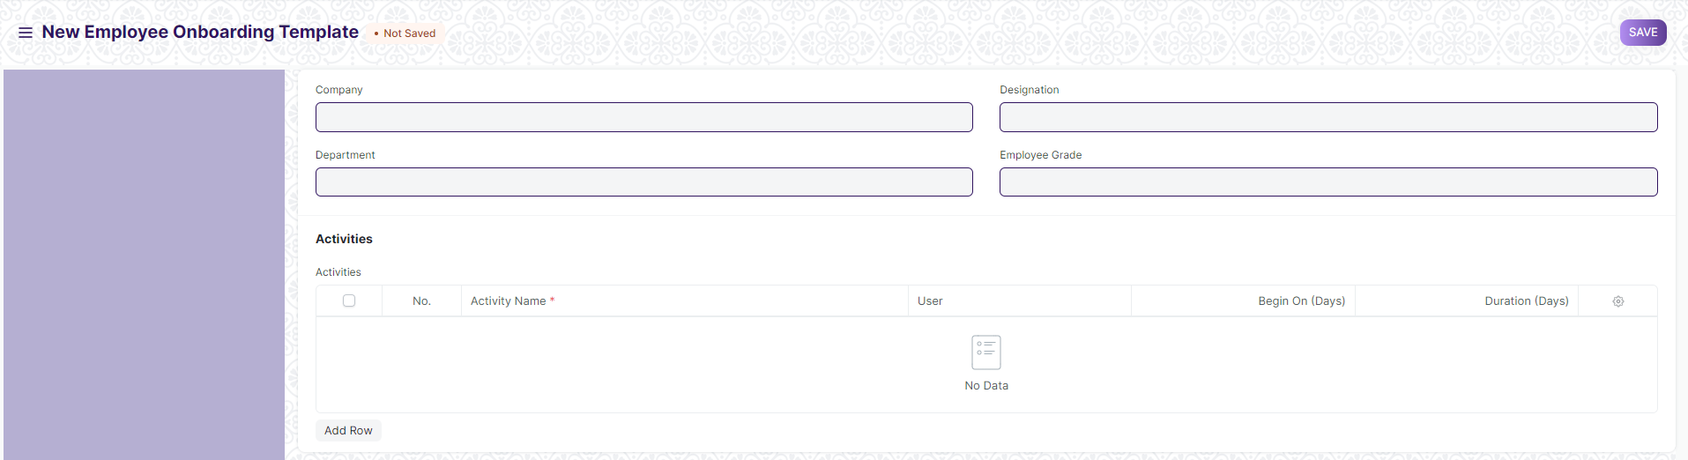

Figure 4: Employee On boarding Template Screen

**Field List**

The following table describes the UI fields present in this screen :

|  |  |  |  |  |  |  |  |  |  |  |  |  |  |
| --- | --- | --- | --- | --- | --- | --- | --- | --- | --- | --- | --- | --- | --- |
| **ID** | | **Label** | **Type** | | **Mandatory** | | | **Validation / Action** | | **Remarks** | | **R= Rename**  **N= New**  **D= Delete** | |
| 1 | | Company | Link | |  | | | Link Field to the Master Screen Company | |  | |  | |
| 2 | | Department | Link | |  | | | Link Field to the Master Screen Department | |  | |  | |
| 3 | | Designation | Link | |  | | | Link Field to the Master Screen Designation | |  | |  | |
| 4 | | Employee Grade | Link | |  | | | Link Field to the Master Screen Employee grade | |  | |  | |
| 5 | | Activities | Table | |  | | |  | | The table is described below. | |  | |
| **Employee Boarding Activity** | | | | | | | | | | | | | |
| **ID** | | **Label** | | | **Type** | | **Mandatory** | **Validation/ Action** | | **Remarks** | | **R = Rename**  **N= New**  **D= Delete** | |
| 1 | | Activity Name | | | Text | | Yes |  | |  | |  | |
| 2 | | User | | | Link | |  | Link Field to the User Screen | |  | |  | |
| 3 | | Begins On (Days) | | | Number | |  |  | |  | |  | |
| 4 | | Duration (Days) | | | Number | |  |  | |  | |  | |
| 5 | | Task | | | Text | |  |  | |  | |  | |

**User: Roles & Permission**

The following table describes the users and their roles and permissions for the screens :

|  |  |  |  |  |  |  |  |  |  |
| --- | --- | --- | --- | --- | --- | --- | --- | --- | --- |
| **ID** | **Role** | **Select** | **Read** | **Write** | **Create** | **Delete** | **Submit** | **Cancel** | **Amend** |
| 1 | HR Admin/Director Admin | Yes | Yes | Yes | Yes | Yes | NA | NA | NA |
| 2 | HR Manager/CS | Yes | Yes | Yes | Yes | Yes | NA | NA | NA |
| 3 | HR Assistant | No | Yes | No | No | No | NA | NA | NA |
| 4 | Employee | No | No | No | No | No | NA | NA | NA |

### Employee Skill Map

**General Description**

The following table describes overall information about this screen:

|  |  |
| --- | --- |
| **Description** | 1. **Employee Skill Map is a record which helps your organization track your Employee's skill sets and training.** 2. **It can be used to rate each skill of the Employee and track their growth after each internal training. This data can be used at the time of appraisals**. |
| **Navigation** | Home > HRMS > Employee Life Cycle> Employee Skill Map |
| **Pre-requisites** | The system should have records in the following screen   1. Employee |
| **Existing Screen Name** | Employee Skill Map |
| **New Screen Name** | No change |

**Screenshot**

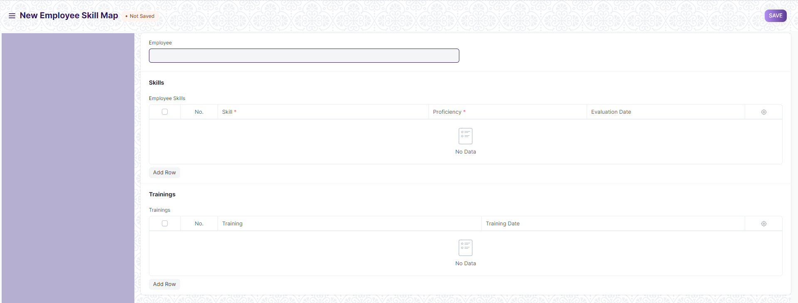

Figure 5: Employee Skill Map Screen

**Field List**

The following table describes the UI fields present in this screen :

|  |  |  |  |  |  |  |  |  |  |  |  |  |  |  |  |  |  |  |  |
| --- | --- | --- | --- | --- | --- | --- | --- | --- | --- | --- | --- | --- | --- | --- | --- | --- | --- | --- | --- |
| **ID** | | | **Label** | | | **Type** | | | **Mandatory** | | | **Validation / Action** | | | **Remarks** | | | **R = Rename**  **N= New**  **D= Delete** | |
| 1 | | | Employee | | | Link | | |  | | | Link Field to Employee Screen. | | |  | | |  | |
| 2 | | | Employee Name | | | Read Only | | |  | | |  | | | Auto Fetched on selection of Employee | | |  | |
| 3 | | | Designation | | | Read Only | | |  | | |  | | | Auto Fetched on selection of Employee | | |  | |
| 4 | | | Employee Skills | | | Table | | |  | | |  | | | The table is described below | | |  | |
| 5 | | | Trainings | | | Table | | |  | | |  | | | The table is described below | | |  | |
| **Employee Skill** | | | | | | | | | | | | | | | | | | | | |
| **ID** | | | **Label** | | **Type** | | | | **Mandatory** | | | **Validation/ Action** | | **Remarks** | | | **R = Rename**  **N= New**  **D= Delete** | | | |
| 1 | | | Skill | | Link | | | | Yes | | | Link Field to Master screen Skill | |  | | |  | | | |
| 2 | | | Proficiency | | Rating | | | | Yes | | |  | |  | | |  | | | |
| 3 | | | Evaluation Date | | Date | | | |  | | | User will select the date | | By default , it takes current date | | |  | | | |
| **Employee Training** | | | | | | | | | | | | | | | | | | | | |
| **ID** | | | **Label** | | | | **Type** | | **Mandatory** | | | **Validation / Action** | | | | **Remarks** | | | **R= Rename**  **N= New**  **D= Delete** | |
| 1 | | | Training | | | | Link | |  | | | Link Field to Training Event Screen | | | |  | | |  | |
| 2 | | | Training Date | | | | Date | |  | | | User will select date | | | | By default it takes current date. | | |  | |

**User: Roles & Permission**

The following table describes the users and their roles and permissions for the screens :

|  |  |  |  |  |  |  |  |  |  |
| --- | --- | --- | --- | --- | --- | --- | --- | --- | --- |
| **ID** | **Role** | **Select** | **Read** | **Write** | **Create** | **Delete** | **Submit** | **Cancel** | **Amend** |
| 1 | HR Admin/Director Admin | Yes | Yes | Yes | Yes | Yes | NA | NA | NA |
| 2 | HR Manager/CS | Yes | Yes | Yes | Yes | No | NA | NA | NA |
| 3 | HR Assistant | No | Yes | No | No | No | NA | NA | NA |
| 4 | Employee | No | Yes | No | No | No | NA | NA | NA |

### Employee Promotion

**General Description**

The following table describes overall information about this screen:

|  |  |
| --- | --- |
| **Description** | 1. Promotion or career advancement is a process through which an Employee of a company is given a higher share of duties, a higher pay-scale or both Enroll button. |
| **Navigation** | Home > HRMS > Employee Life Cycle > Employee promotion |
| **Pre-requisites** | The system should have records in the following screen   1. Employee 2. Department |
| **Existing Screen Name** | Employee Promotion |
| **New Screen Name** | No change |

**Screenshot**

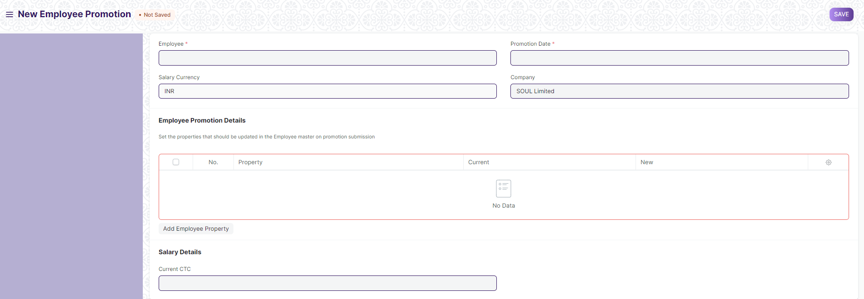

Figure 6: Employee Promotion Screen

**Field List**

The following table describes the UI fields present in this screen :

|  |  |  |  |  |  |  |  |  |  |  |  |
| --- | --- | --- | --- | --- | --- | --- | --- | --- | --- | --- | --- |
| **ID** | **Label** | | | **Type** | | **Mandatory** | | **Validation / Action** | **Remarks** | **R= Rename**  **N= New**  **D= Delete** | |
| 1 | Employee | | | Link | | Yes | | Link Field to master screen Employee |  |  | |
| 2 | Employee Name | | | Text | |  | |  | Auto Fetched on selection of Employee |  | |
| 3 | Department | | | Link | |  | | Link Field to master screen Department | Auto Fetched on selection of employee |  | |
| 4 | Salary Currency | | | Link | |  | | Link Field to Currency screen |  |  | |
| 5 | Promotion Date | | | Date | | Yes | | User will input the date |  |  | |
| 6 | Company | | | Link | |  | | Link to master screen Company |  |  | |
| 7 | Employee Promotion Details | | | Table | |  | |  | The table is described below. |  | |
| 8 | Current CTC | | | Currency | |  | |  | Auto Fetched on selection of Employee. |  | |
| 9 | Revised CTC | | | Currency | |  | | User will give input. |  |  | |
| **Employee Training** | | | | | | | | | | | |
| **ID** | | | **Label** | **Type** | | **Mandatory** | | **Validation / Action** | | **Remarks** | **R= Rename**  **N= New**  **D= Delete** |
| 1 | | | Property | Drop down | |  | | User will select which property needs to be changed. | |  |  |
| 2 | | | Current | Text | |  | |  | | Auto Fetched on selecting Property |  |
| 3 | | | New | Text | |  | |  | |  |  |

**User: Roles & Permission**

The following table describes the users and their roles and permissions for the screens :

|  |  |  |  |  |  |  |  |  |
| --- | --- | --- | --- | --- | --- | --- | --- | --- |
| **Role** | **Select** | **Read** | **Write** | **Create** | **Delete** | **Submit** | **Cancel** | **Amend** |
| HR Admin/Director Admin | Yes | Yes | Yes | Yes | Yes | Yes | Yes | Yes |
| HR Manager/CS | No | Yes | Yes | Yes | No | Yes | Yes | No |
| HR Assistant | No | Yes | No | No | No | No | No | No |
| Employee | No | Yes | No | No | No | No | No | No |

### Employee Transfer

**General Description**

The following table describe overall information about this screen:

|  |  |
| --- | --- |
| **Description** | 1. Employee Transfer is a form of internal mobility, in which the Employee is shifted from one job to another usually at a different location, department, or unit. |
| **Navigation** | Home > HRMS > Employee Life cycle > Employee Transfer |
| **Pre-requisites** | The system should have records in the following screen   1. Employee 2. Department |
| **Existing Screen Name** | Employee Transfer |
| **New Screen Name** | No change |

**Screenshot**

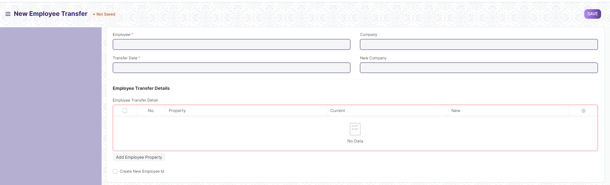

Figure7 : Employee Transfer Screen

**Field List**

The following table describes the UI fields present in this screen :

|  |  |  |  |  |  |  |
| --- | --- | --- | --- | --- | --- | --- |
| **ID** | **Label** | **Type** | **Mandatory** | **Validation / Action** | **Remarks** | **R= Rename**  **N= New**  **D= Delete** |
| 1 | Employee | Link | Yes | Link Fields to Master Screen Employee |  |  |
| 2 | Employee Name | Text |  |  | Auto Fetched on selection of Employee |  |
| 3 | Transfer Date | Date | Yes | User will give input |  |  |
| 4 | Company | Link |  | Link Field to Master Screen Company |  |  |
| 5 | New Company | Link |  | Link Field to master screen Company |  |  |
| 6 | Department | Link |  | Link Field to master screen Department |  |  |
| 7 | Employee Transfer Detail | Table |  |  | The table is described below. |  |
| 8 | Create New Employee Id | Checkbox |  |  | If Checked, then new employee id will be assigned to the employee |  |
| 9 | New Employee ID | Link |  | Link Field to master screen Employee |  |  |

|  |  |  |  |  |  |  |
| --- | --- | --- | --- | --- | --- | --- |
| **Employee Property History** | | | | | | |
| **ID** | **Label** | **Type** | **Mandatory** | **Validation / Action** | **Remarks** | **R= Rename**  **N= New**  **D= Delete** |
| 1 | Property | Drop down |  | User will select which property needs to be changed. |  |  |
| 2 | Current | Text |  |  | Auto Fetched on selecting Property |  |
| 3 | New | Text |  |  |  |  |

**User: Roles & Permission**

The following table describes the users and their roles and permissions for the screens :

|  |  |  |  |  |  |  |  |  |  |
| --- | --- | --- | --- | --- | --- | --- | --- | --- | --- |
| **ID** | **Role** | **Select** | **Read** | **Write** | **Create** | **Delete** | **Submit** | **Cancel** | **Amend** |
| 1 | HR Admin/Director Admin | Yes | Yes | Yes | Yes | Yes | Yes | Yes | Yes |
| 2 | HR Manager/CS | No | Yes | Yes | Yes | No | Yes | Yes | No |
| 3 | HR Assistant | No | Yes | No | No | No | No | No | No |
| 4 | Employee | No | Yes | No | No | No | No | No | No |

### Employee Grievance

**General Description**

The following table describe overall information about this screen:

|  |  |
| --- | --- |
| **Description** | 1. The employees of an organization can raise grievances and after investigation actions like pay cut and suspension can be taken and recorded |
| **Navigation** | Home > HRMS > Employee Life cycle > Employee Grievance |
| **Pre-requisites** | The system should have records in the following screen   1. Grievance Type 2. Employee |
| **Existing Screen Name** | Employee Grievance |
| **New Screen Name** | No change |

**Screenshot**

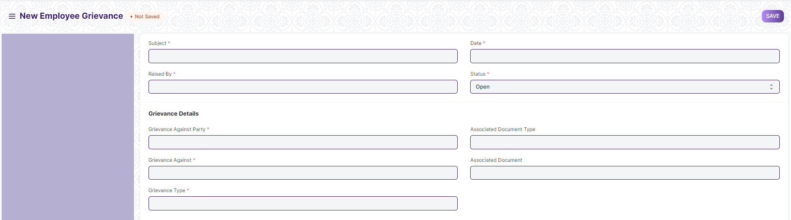

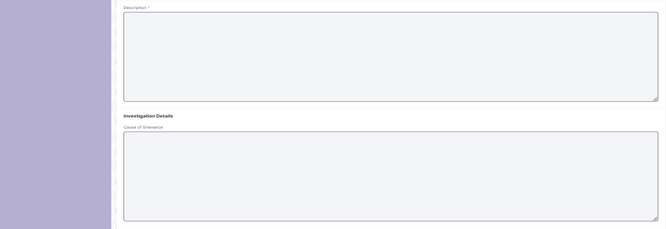



Figure 8 : Employee Grievance Screen

**Field List**

The following table describes the UI fields present in this screen :

|  |  |  |  |  |  |  |
| --- | --- | --- | --- | --- | --- | --- |
| **ID** | **Label** | **Type** | **Mandatory** | **Validation / Action** | **Remarks** | **R= Rename**  **N= New**  **D= Delete** |
| 1 | Subject | Text | Yes |  |  |  |
| 2 | Raised By | Link | Yes | Link Field to master screen Employee |  |  |
| 3 | Employee Name | Text |  |  | Auto Fetched on selection of employee |  |
| 4 | Designation | Link |  | Link Field to master screen Designation |  |  |
| 5 | Date | Date | Yes | User will input date |  |  |
| 6 | Status | Drop down | Yes | Options :  Open  Investigated  Resolved  Invalid |  |  |
| 7 | Reports To | Link |  | Link to master screen Employee |  |  |
| 8 | Grievance Against Party | Link | Yes | Link with all the master screens in which the employee is linked. |  |  |
| 9 | Grievance Against | Link | Yes | Link field to the selection of grievance against party. |  |  |
| 10 | Grievance Type | Link | Yes | Link Field to master screen Grievance Type |  |  |
| 11 | Associated Document Type | Link |  | Link Field to all the screens. |  |  |
| 12 | Associated Document | Link |  | Link Field to the selected Associated Document Type |  |  |
| 13 | Description | Text | Yes |  |  |  |
| 14 | Cause of Grievance | Text |  |  |  |  |
| 15 | Resolved By | Link | Yes | Link Field to master screen user |  |  |
| 16 | Resolution Date | Date |  |  |  |  |
| 17 | Employee Responsible | Link |  | Link Field to master screen Employee |  |  |
| 18 | Resolution Details | Text |  |  |  |  |
| 19 | Grievance Related Document | Attachment |  | User will attach the grievance related document |  | N |

**User: Roles & Permission**

The following table describes the users and their roles and permissions for the screens :

|  |  |  |  |  |  |  |  |  |  |
| --- | --- | --- | --- | --- | --- | --- | --- | --- | --- |
| **ID** | **Role** | **Select** | **Read** | **Write** | **Create** | **Delete** | **Submit** | **Cancel** | **Amend** |
| 1 | HR Admin/Director Admin | Yes | Yes | Yes | Yes | Yes | Yes | Yes | Yes |
| 2 | HR Manager/CS | No | Yes | Yes | Yes | No | Yes | No | No |
| 3 | HR Assistant | No | Yes | No | No | No | No | No | No |
| 4 | Employee | No | Yes | No | Yes | No | Yes | No | No |

### Employee Separation Template

**General Description**

The following table describe overall information about this screen:

|  |  |
| --- | --- |
| **Description** | 1. The Employee Separation Template is a blueprint which contains a predefined list of Activities for Employee Separation. An Employee Separation Template can be created for a particular Department, Designation and Employee Grade. |
| **Navigation** | Home > HRMS > Employee Life cycle > Employee Separation Template |
| **Pre-requisites** | The system should have records in the following screen   1. Company 2. Department 3. Designation |
| **Existing Screen Name** | Employee Separation Template |
| **New Screen Name** | No change |

**Screenshot**

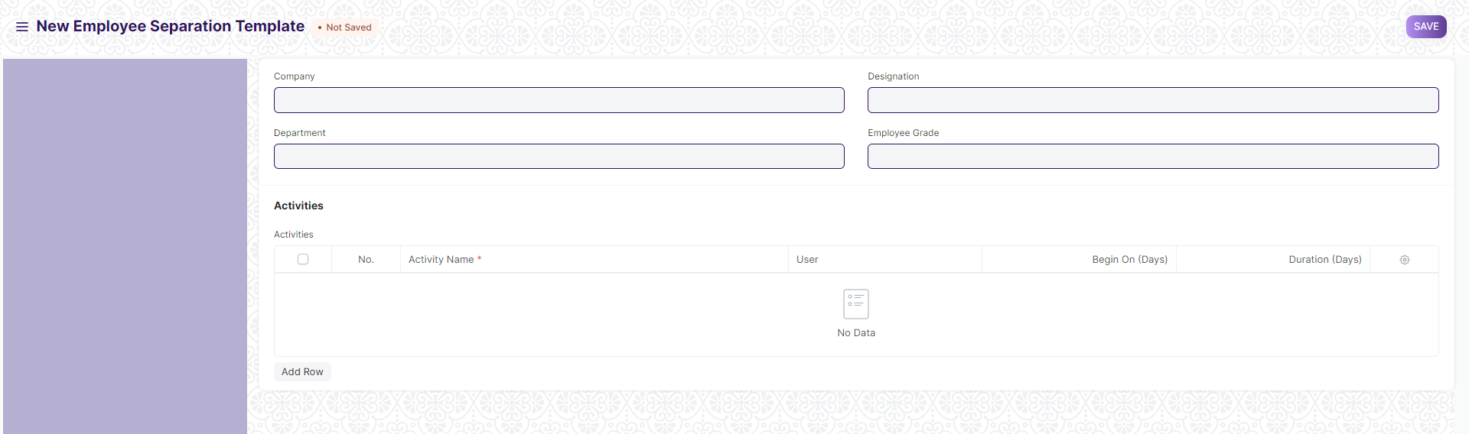

Figure 9 : Employee Separation Template Screen

**Field List**

The following table describes the UI fields present in this screen :

|  |  |  |  |  |  |  |
| --- | --- | --- | --- | --- | --- | --- |
| **ID** | **Label** | **Type** | **Mandatory** | **Validation / Action** | **Remarks** | **R= Rename**  **N= New**  **D= Delete** |
| 1 | Company | Link |  | Link Field to master screen Company |  |  |
| 2 | Department | Link |  | Link Field to master screen Department |  |  |
| 3 | Designation | Link |  | Link Field to master screen Designation |  |  |
| 4 | Employee Grade | Link |  | Link field to master screen Employee Grade |  |  |
| 5 | Activities | Table |  |  | The table is described below |  |

|  |  |  |  |  |  |  |
| --- | --- | --- | --- | --- | --- | --- |
| **Employee Boarding Activity** | | | | | | |
| **ID** | **Label** | **Type** | **Mandatory** | **Validation / Action** | **Remarks** | **R= Rename**  **N= New**  **D= Delete** |
| 1 | Activity Name | Text | Yes |  |  |  |
| 2 | User | Link |  | Link Field to User Screen |  |  |
| 3 | Begins On (Days) | Number |  |  |  |  |
| 4 | Duration (Days) | Number |  |  |  |  |
| 5 | Task | Text |  |  |  |  |

**User: Roles & Permission**

The following table describes the users and their roles and permissions for the screens :

|  |  |  |  |  |  |  |  |  |  |
| --- | --- | --- | --- | --- | --- | --- | --- | --- | --- |
| **ID** | **Role** | **Select** | **Read** | **Write** | **Create** | **Delete** | **Submit** | **Cancel** | **Amend** |
| 1 | HR Admin/Director Admin | Yes | Yes | Yes | Yes | Yes | NA | NA | NA |
| 2 | HR Manager/CS | Yes | Yes | Yes | Yes | No | NA | NA | NA |
| 3 | HR Assistant | No | Yes | No | No | No | NA | NA | NA |
| 4 | Employee | No | No | No | No | No | NA | NA | NA |

### Employee Separation

**General Description**

The following table describe overall information about this screen:

|  |  |
| --- | --- |
| **Description** | 1. Employee Separation is a situation when the service agreement of an Employee with his/her organization comes to an end and the Employee leaves the organization. 2. Employee Separation is created for an Employee who has resigned or terminated from the organization. |
| **Navigation** | Home > HRMS > Employee Life cycle > Employee Separation |
| **Pre-requisites** | The system should have records in the following screen   1. Employee 2. Department 3. Designation 4. Employee Grade |
| **Existing Screen Name** | Employee Separation |
| **New Screen Name** | No change |

**Screenshot**

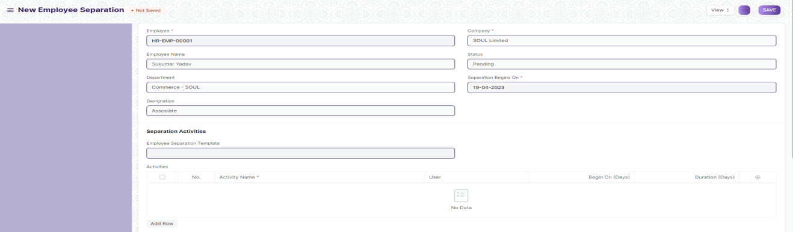

Figure 10 : Employee Separation Screen

**Field List**

The following table describes the UI fields present in this screen :

|  |  |  |  |  |  |  |
| --- | --- | --- | --- | --- | --- | --- |
| **ID** | **Label** | **Type** | **Mandatory** | **Validation / Action** | **Remarks** | **R= Rename**  **N= New**  **D= Delete** |
| 1 | Employee | Link | Yes | Link Field to master screen Employee |  |  |
| 2 | Employee Name | Text |  |  | Auto Fetched on selection of employee |  |
| 3 | Department | Link |  | Link Field to master screen Department | Auto Fetched on selection of employee |  |
| 4 | Designation | Link |  | Link Field to master screen Designation | Auto Fetched on selection of Employee |  |
| 5 | Employee Grade | Link |  | Link Field to the master screen Employee grade | Auto Fetched on selection of Employee |  |
| 6 | Company | Link F | Yes | Link Field to the master screen Company | Auto Fetched on selection of employee |  |
| 7 | Status | Drop down |  | Options :  Pending  In Process  Completed  Canceled. |  |  |
| 8 | Resignation Letter Date | Date |  |  |  |  |
| 9 | Separation Begins On | Date | Yes |  |  |  |
| 10 | Final Working Date |  | Yes |  |  | N |
| 11 | Project | Link |  | Link Field to screen Project |  |  |
| 12 | Employee Separation Template | Link |  | Link Field to screen Employee Separation Template |  |  |
| 13 | Activities | Table |  |  | The table is described below |  |
| 14 | Reason of Separation | Text |  |  |  | N |
| 15 | Separation Documents | Attachment |  |  |  | N |
| 16 | Notify users by email | Checkbox |  | If checked , then a mail will be triggered to the employee. |  |  |
| 17 | Exit Interview Summary | Text Editor |  |  |  |  |

|  |  |  |  |  |  |  |  |  |
| --- | --- | --- | --- | --- | --- | --- | --- | --- |
| **Employee Boarding Activity** | | | | | | | | |
| **ID** | | **Label** | **Type** | **Mandatory** | **Validation / Action** | | **Remarks** | **R= Rename**  **N= New**  **D= Delete** |
| 1 | | Activity Name | Text | Yes |  | |  |  |
| 2 | | User | Link |  | Link Field to User Screen | |  |  |
| 3 | | Begins On (Days) | Number |  |  | |  |  |
| 4 | | Duration (Days) | Number |  |  | |  |  |
| 5 | | Task | Text |  |  | |  |  |
| 6 | | Status | Drop down |  | Options :  Completed  Not completed  Not applicable | |  | N |
| **Action Button** | | | | | **Description** | | |
| Forward to Department Head | | | | | On clicking the button, the form will be forwarded to department head , after verification done by reporting authority. | | |
| Rejected | | | | | On clicking the button, the separation process will be terminated. The status field in the screen will be updated to Canceled. | | |
| Approved | | | | | On clicking the button , the separation process will be approved.The status in the form will be completed. | | |

**Note** :

On submitting employee separation form, it will be forwarded to the immediate reporting authority. Reporting authority will verify the documents and the activities . After verification , it will be forwarded to the department head. Department head will decide the action (Approve/Reject) to do. If the department head approves , it will again forwarded to HR and HR will forward It the individual departments for clearance.

**User: Roles & Permission**

The following table describes the users and their roles and permissions for the screens :

|  |  |  |  |  |  |  |  |  |  |
| --- | --- | --- | --- | --- | --- | --- | --- | --- | --- |
| **ID** | **Role** | **Select** | **Read** | **Write** | **Create** | **Delete** | **Submit** | **Cancel** | **Amend** |
| 1 | HR Admin/Director Admin | Yes | Yes | Yes | Yes | Yes | Yes | Yes | Yes |
| 2 | HR Manager/CS | No | Yes | Yes | Yes | No | Yes | Yes | No |
| 3 | HR Assistant | No | Yes | No | No | No | No | No | No |
| 4 | Employee | No | Yes | No | No | No | No | No | No |

### Employee Re-engagement

**General Description**

The following table describe overall information about this screen:

|  |  |
| --- | --- |
| **Description** | 1. This form will be used for employees to apply for re-engagement. |
| **Navigation** | Home > HRMS > Employee Life cycle > Employee Re-engagement |
| **Pre-requisites** | The system should have records in the following screen   1. Employee 2. Department 3. Employment Type |
| **Existing Screen Name** | NA |
| **New Screen Name** | Employee Re-engagement |

**Screenshot**

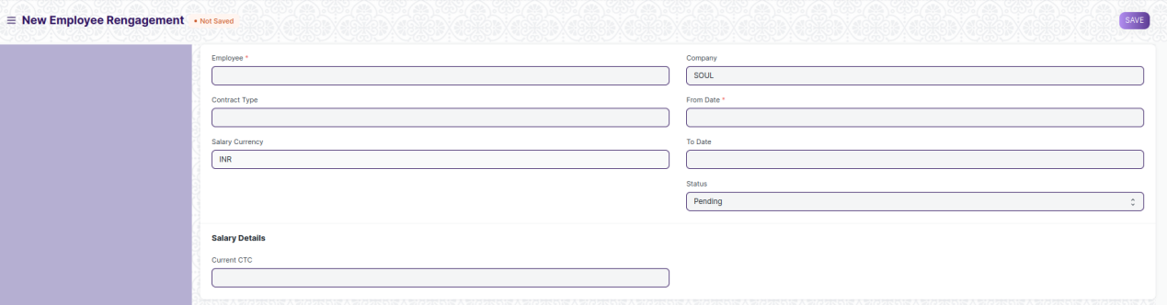

Figure 11 : Employee Re-engagement Screen

**Field List**

The following table describes the UI fields present in this screen :

|  |  |  |  |  |  |  |
| --- | --- | --- | --- | --- | --- | --- |
| **ID** | **Label** | **Type** | **Mandatory** | **Validation / Action** | **Remarks** | **R= Rename**  **N= New**  **D= Delete** |
| 1 | Employee | Link | Yes | Link Field to master screen employee |  | N |
| 2 | Employee Name | Text |  |  | Auto Fetched on selection of Employee | N |
| 3 | Department | Link |  | Link Field to the master screen department | The department type of the selected employee will be auto fetched. | N |
| 4 | Contract Type | Link |  | Link field to the master screen Employment Type | The employment type of the selected employee will be auto fetched. | N |
| 5 | Salary Currency | Link |  | Link Field to the Currency Screen |  | N |
| 6 | Company | Link |  | Link Field to the master screen company | The company of the selected employee will be auto fetched. | N |
| 7 | From Date | Date |  |  | Old contract start date will be fetched | N |
| 8 | To Date | Date |  |  | Old contract end date will be fetched | N |
| 9 | Status | Drop down |  | Options :   1. Pending 2. Forwarded to Reporting Authority 3. Forwarded to Department Head 4. Approved | By default : Pending | N |
| 10 | Current CTC | Currency |  |  | Current ctc of employee will be fetched | N |
| 11 | Revised CTC | Currency |  | Employee will input the revised ctc. |  | N |

|  |  |
| --- | --- |
| **Action Button** | **Description** |
| Forward to Department Head | On clicking it , the form will be forwarded to the department head for approval. The status in the form will updated to Forwarded to Department Head. |
| Rejected | On clicking Approved, the status in the form will be updated to Approved. |
| Approved | On Clicking Reject, the status in the form will be updated to Rejected. |

**User: Roles & Permission**

The following table describes the users and their roles and permissions for the screens :

|  |  |  |  |  |  |  |  |  |  |
| --- | --- | --- | --- | --- | --- | --- | --- | --- | --- |
| **ID** | **Role** | **Select** | **Read** | **Write** | **Create** | **Delete** | **Submit** | **Cancel** | **Amend** |
| 1 | HR Admin/Director Admin | Yes | Yes | Yes | Yes | Yes | Yes | Yes | Yes |
| 2 | HR Manager/CS | No | Yes | Yes | Yes | No | Yes | Yes | No |
| 3 | HR Assistant | No | Yes | Yes | Yes | No | Yes | No | No |
| 4 | Employee | No | Yes | Yes | Yes | No | Yes | No | No |

### Staff Suggestion

**General Description**

The following table describe overall information about this screen:

|  |  |
| --- | --- |
| **Description** | 1. This screen will help all the staffs to suggest something for the development of company policy . |
| **Navigation** | Home > HRMS > Employee Life cycle > Staff Suggestion |
| **Pre-requisites** | The system should have records in the following screen   1. Employee   2. Department |
| **Existing Screen Name** | NA |
| **New Screen Name** | Staff Suggestion |

**Screenshot**

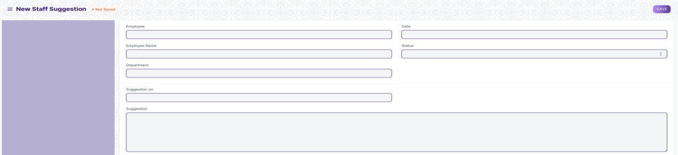

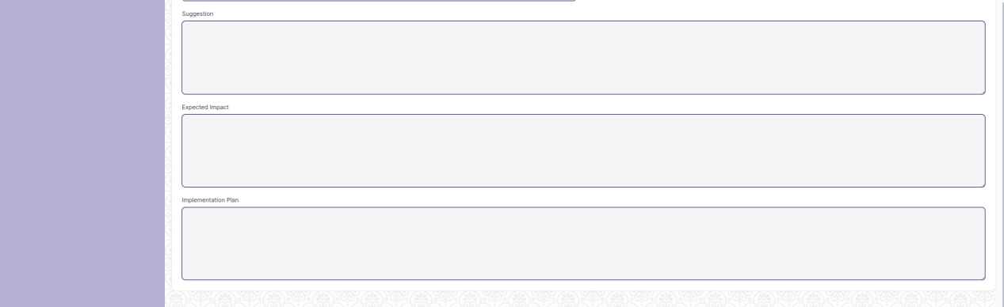

Figure 12 : Staff Suggestion Screen

**Field List**

The following table describes the UI fields present in this screen :

|  |  |  |  |  |  |  |
| --- | --- | --- | --- | --- | --- | --- |
| **ID** | **Label** | **Type** | **Mandatory** | **Validation / Action** | **Remarks** | **R= Rename**  **N= New**  **D= Delete** |
|  | Employee | Link | Yes | Link Field to Employee Screen |  | N |
| 1 | Employee Name | Text |  |  | Auto Fetched on selection of Employee | N |
| 2 | Department | Data |  |  | Auto Fetched on selection of Employee | N |
| 3 | Date | Date |  |  | By default current date | N |
| 4 | Status | Drop down |  | Options :   1. Suggested 2. Approved 3. Rejected | By default “Suggested” | N |
| 5 | Suggestion on | Link |  | Link filed to all the fields in which the employee want to suggest |  | N |
| 6 | Suggestion | Text |  |  |  | N |
| 7 | Expected Impact | Text |  |  |  | N |
| 8 | Implementation Plan | Text |  |  |  | **N** |

|  |  |
| --- | --- |
| **Action Button** | **Description** |
| Approved | On clicking Approved , the status in the form will be updated to Approve. The higher authority will only be able to approve . |
| Rejected | On clicking Rejected, the status in the form will be updated to rejected. The higher authority will only be able to reject. |

**User: Roles & Permission**

The following table describes the users and their roles and permissions for the screens :

|  |  |  |  |  |  |  |  |  |  |
| --- | --- | --- | --- | --- | --- | --- | --- | --- | --- |
| **ID** | **Role** | **Select** | **Read** | **Write** | **Create** | **Delete** | **Submit** | **Cancel** | **Amend** |
| 1 | HR Admin/Director Admin | Yes | Yes | Yes | Yes | Yes | Yes | Yes | Yes |
| 2 | HR Manager/CS | Yes | Yes | Yes | Yes | Yes | Yes | Yes | No |
| 3 | HR Assistant | No | Yes | Yes | Yes | No | Yes | No | No |
| 4 | Employee | No | Yes | Yes | Yes | No | Yes | No | No |

### Employee Resignation

**General Description**

The following table describe overall information about this screen:

|  |  |
| --- | --- |
| **Description** | 1. A resignation form is a form that gives notice to an entity or organization of an employee's intent to quit their job. 2. The objective of a resignation form, aside from informing the company of the employee's resignation, is to maintain a positive relationship between the two parties |
| **Navigation** | Home > HRMS > Employee Life Cycle > Employee Resignation |
| **Pre-requisites** | The system should have records in the following screen   1. Employee 2. Department 3. Employment Type |
| **Existing Screen Name** | NA |
| **New Screen Name** | Employee Resignation |

**Screenshot**

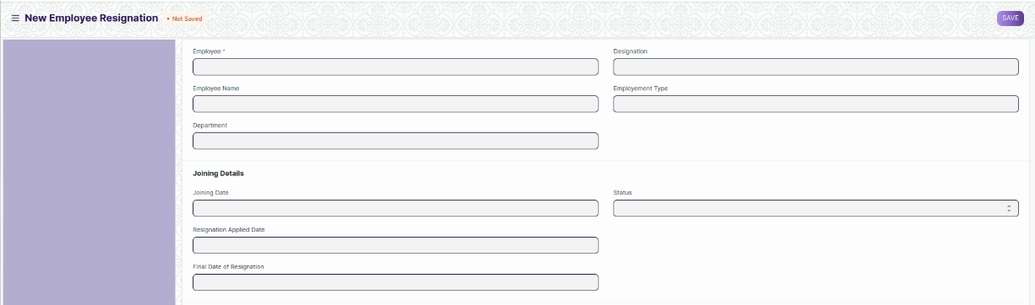



Figure 13 : Employee Resignation Screen

**Field List**

The following table describes the UI fields present in this screen :

|  |  |  |  |  |  |  |
| --- | --- | --- | --- | --- | --- | --- |
| **ID** | **Label** | **Type** | **Mandatory** | **Validation / Action** | **Remarks** | **R= Rename**  **N= New**  **D= Delete** |
| 1 | Employee | Link | Yes | Link Field to the master screen Employee |  | N |
| 2 | Employee Name | Text |  |  | Auto Fetched on selection of Employee | N |
| 3 | Department | Text |  |  | Auto fetched on selection of Employee | N |
| 4 | Designation | Text |  |  | Auto Fetched on selection of Employee | N |
| 5 | Employment Type | Text |  |  | Auto Fetched on selection of employee | N |
| 6 | Joining Date | Text |  |  | Auto Fetched on selection of employee | N |
| 7 | Resignation Applied Date | Date |  |  |  | N |
| 8 | Final Date of Resignation | Date |  |  |  | N |
| 9 | Status | Drop down |  | Options :  Approved  Rejected |  | N |
| 10 | Reason of Resignation | Text |  |  |  | N |
| 11 | Upload Document | Attachment |  |  |  | N |

|  |  |
| --- | --- |
| **Action Button** | **Description** |
| Approve | On Clicking the button, the application status will change to Approved , and the separation process will begin. |
| Reject | On clicking the button, the application status will change to Rejected, and the separation process will be terminated.(With drawl of resignation) |

**User: Roles & Permission**

The following table describes the users and their roles and permissions for the screens :

|  |  |  |  |  |  |  |  |  |  |
| --- | --- | --- | --- | --- | --- | --- | --- | --- | --- |
| **ID** | **Role** | **Select** | **Read** | **Write** | **Create** | **Delete** | **Submit** | **Cancel** | **Amend** |
| 1 | HR Admin/Director Admin | Yes | Yes | Yes | Yes | Yes | Yes | Yes | Yes |
| 2 | HR Manager/CS | No | Yes | Yes | Yes | No | Yes | Yes | No |
| 3 | HR Assistant | No | Yes | No | No | No | No | No | No |
| 4 | Employee | No | Yes | No | No | No | No | No | No |

### Employee Profile Updation

**General Description**

The following table describe overall information about this screen:

|  |  |
| --- | --- |
| **Description** | 1. Employee Profile Updation helps an employee to request to update his profile information. |
| **Navigation** | Home > HRMS> Employee Life cycle> Employee Profile Updation |
| **Pre-requisites** | The system should have records in the following screen   1. Employee |
| **Existing Screen Name** | NA |
| **New Screen Name** | Employee Profile Updation |

**Screenshot**

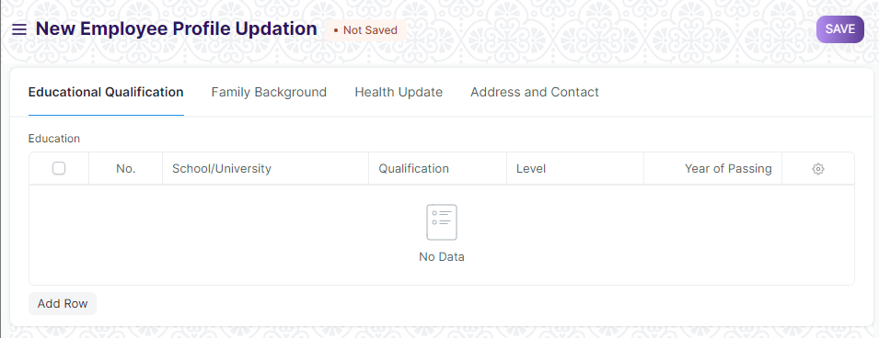

Figure 14: Employee Profile Updation Screen

**Field List**

The following table describes the UI fields present in this screen :

|  |  |  |  |  |  |  |
| --- | --- | --- | --- | --- | --- | --- |
| **ID** | **Label** | **Type** | **Mandatory** | **Validation / Action** | **Remarks** | **R= Rename**  **N= New**  **D= Delete** |
| 1 | Employee | Link |  | Link to master screen Employee |  | N |
| 2 | Employee Name | Link |  | Employee name will be auto-populated on the basis of Employee Id Selected. |  | N |
| 3 | Department | Text |  | Department will be auto-populated on the basis of Employee Id Selected. |  | N |
| 4 | Employment Type | Text |  | Employment type will be auto-populated on the basis of Employee Id. |  | N |
| 5 | Educational Qualification | Table |  |  | This table is described below | N |
| 6 | Family Background | Table |  |  | This table is described below | N |
| 7 | Health Update | Table |  |  | This table is described below | N |
| 8 | Current Address | Small Text |  |  |  | N |
| 9 | Permanent Address | Small Text |  |  |  | N |
| 10 | Emergency Phone | Number |  |  |  | N |

|  |  |  |  |  |  |  |  |
| --- | --- | --- | --- | --- | --- | --- | --- |
| **Education Qualification Details** | | | | | | | |
| **ID** | **Label** | **Type** | **Mandatory** | | **Validation/ Action** | **Remarks** | **R = Rename**  **N= New**  **D= Delete** |
| 1 | School/University | Small Text | Yes | |  |  | N |
| 2 | Qualification | Text | Yes | |  |  | N |
| 3 | Level | Dopdown | Yes | | **Options:**  Graduate  Post Graduate  Under Graduate |  | N |
| 4 | Year of Passing | Number | Yes | |  |  | N |
| 5 | Class / Percentage | Number | Yes | |  |  | N |
| 6 | Major/Optional Subjects | Text | Yes | |  |  | N |
| **Family Background Details** | | | | | | | |
| **ID** | **Label** | **Type** | **Mandatory** | | **Validation/ Action** | **Remarks** | **R = Rename**  **N= New**  **D= Delete** |
| 1 | Name | Text | Yes | |  |  | N |
| 2 | Relation | Text | Yes | |  |  | N |
| 3 | Occupation | Text | Yes | |  |  | N |
| 4 | Gender | Link | Yes | | Link to the screen Gender |  |  |
| 5 | Contact | Number | Yes | |  |  | N |
| 6 | Date of Birth | Date | Yes | |  |  | N |
| 7 | Annual Income | Number |  | |  |  | N |
| **Health Details** | | | | | | | |
| **ID** | **Label** | **Type** | **Mandatory** | | **Validation/ Action** | **Remarks** | **R = Rename**  **N= New**  **D= Delete** |
| 1 | Disease name | Text | Yes | |  |  | N |
| 2 | Description | Text Editor | Yes | |  |  | N |
| 3 | Recommendation by Physician | Text |  | |  |  | N |
| 4 | Attach |  |  | |  |  | N |
| **Action Button** | | | | **Description** | | | |
| Approve | | | | On Clicking the button, the application status will change to Approved , and the data in the profile will be updated. | | | |
| Reject | | | | On clicking the button, the application status will change to Rejected, and the the data in the profile will not be updated. | | | |

**User: Roles & Permission**

The following table describes the users and their roles and permissions for the screens :

|  |  |  |  |  |  |  |  |  |  |
| --- | --- | --- | --- | --- | --- | --- | --- | --- | --- |
| **ID** | **Role** | **Select** | **Read** | **Write** | **Create** | **Delete** | **Submit** | **Cancel** | **Amend** |
| 1 | HR Admin/Director Admin | No | Yes | Yes | Yes | Yes | Yes | Yes | Yes |
| 2 | HR Manager/CS | No | Yes | Yes | Yes | Yes | Yes | Yes | No |
| 3 | HR Assistant | No | Yes | No | Yes | No | Yes | No | No |
| 4 | Employee | No | Yes | No | Yes | No | Yes | No | No |

### Appraisal Template

**General Description**

The following table describe overall information about this screen:

|  |  |
| --- | --- |
| **Description** | 1. Appraisal Template screen is used for creating an Appraisal Template for each role with the parameters that define the performance by giving appropriate weightage to each parameter. |
| **Navigation** | Home > HRMS > Employee Life Cycle > Appraisal Template |
| **Pre-requisites** | The system should have records in the following screen   1. Employee |
| **Existing Screen Name** | Appraisal Template |
| **New Screen Name** | No change |

**Screenshot**

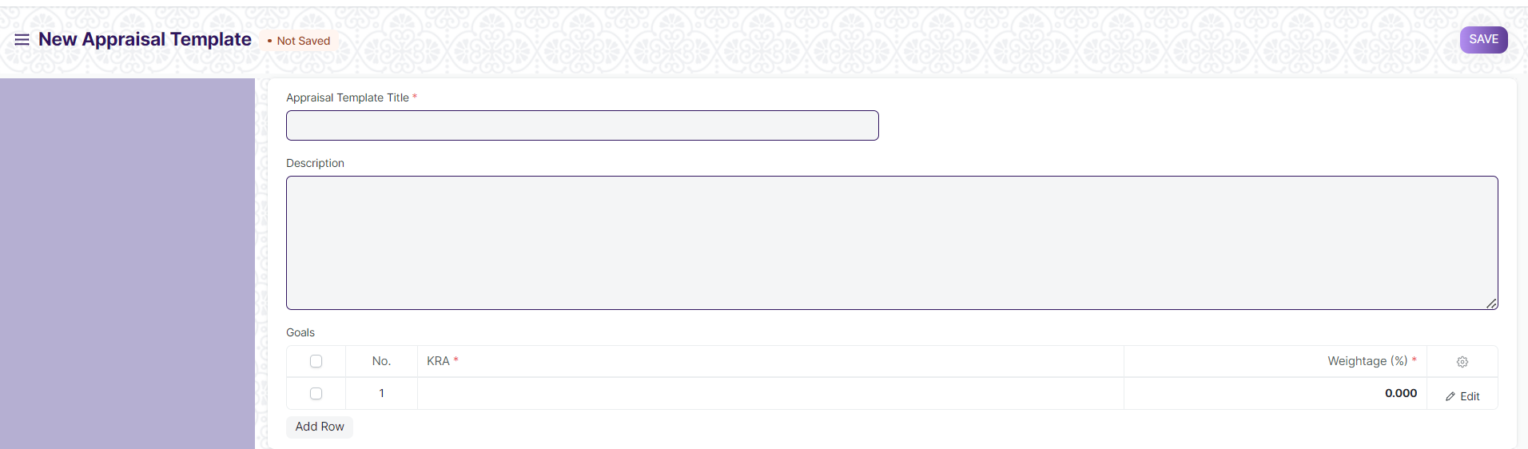

Figure 15 : Appraisal Template Screen

**Field List**

The following table describes the UI fields present in this screen :

|  |  |  |  |  |  |  |  |  |  |  |  |  |  |  |  |  |  |  |  |  |  |  |  |  |  |  |  |  |  |  |  |  |  |  |
| --- | --- | --- | --- | --- | --- | --- | --- | --- | --- | --- | --- | --- | --- | --- | --- | --- | --- | --- | --- | --- | --- | --- | --- | --- | --- | --- | --- | --- | --- | --- | --- | --- | --- | --- |
| |  |  |  |  |  |  |  | | --- | --- | --- | --- | --- | --- | --- | | **ID** | **Label** | **Type** | **Mandatory** | **Validation / Action** | **Remarks** | **R= Rename**  **N= New**  **D= Delete** | | 1 | Appraisal Template Title | Text | Yes | User will give the name of Appraisal Template |  |  | | 2 | Description | Small Text |  |  |  |  | | 3 | Goals | Table | Yes |  | The table is described below. |  |   **Appraisal Template Goals** | | | | | | |
| **ID** | **Label** | **Type** | **Mandatory** | **Validation/ Action** | **Remarks** | **R = Rename**  **N= New**  **D= Delete** |
| 1 | KRA | Small Text | Yes | User will set the KRA |  |  |
| 2 | Weightage | Number | Yes | User will set the weightage |  |  |

**Note :**

The appraisal template has been shared by WSC.

**User: Roles & Permission**

The following table describes the users and their roles and permissions for the screens :

|  |  |  |  |  |  |  |  |  |  |
| --- | --- | --- | --- | --- | --- | --- | --- | --- | --- |
| **ID** | **Role** | **Select** | **Read** | **Write** | **Create** | **Delete** | **Submit** | **Cancel** | **Amend** |
| 1 | HR Admin/Director Admin | Yes | Yes | Yes | Yes | Yes | NA | NA | NA |
| 2 | HR Manager/CS | Yes | Yes | Yes | Yes | Yes | NA | NA | NA |
| 3 | HR Assistant | No | Yes | No | No | No | NA | NA | NA |
| 4 | Employee | No | Yes | No | No | No | NA | NA | NA |

### Appraisal

**General Description**

The following table describe overall information about this screen:

|  |  |
| --- | --- |
| **Description** | 1. A performance appraisal is a method by which the job performance of an employee is documented and evaluated. 2. User can manage Employee Appraisals by creating an Appraisal Template for each role with the parameters that define the performance by giving appropriate weightage to each parameter. |
| **Navigation** | Home > HRMS > Employee Life Cycle > Appraisal |
| **Pre-requisites** | The system should have records in the following screen   1. Employee |
| **Existing Screen Name** | Appraisal |
| **New Screen Name** | NA |

**Screenshot**

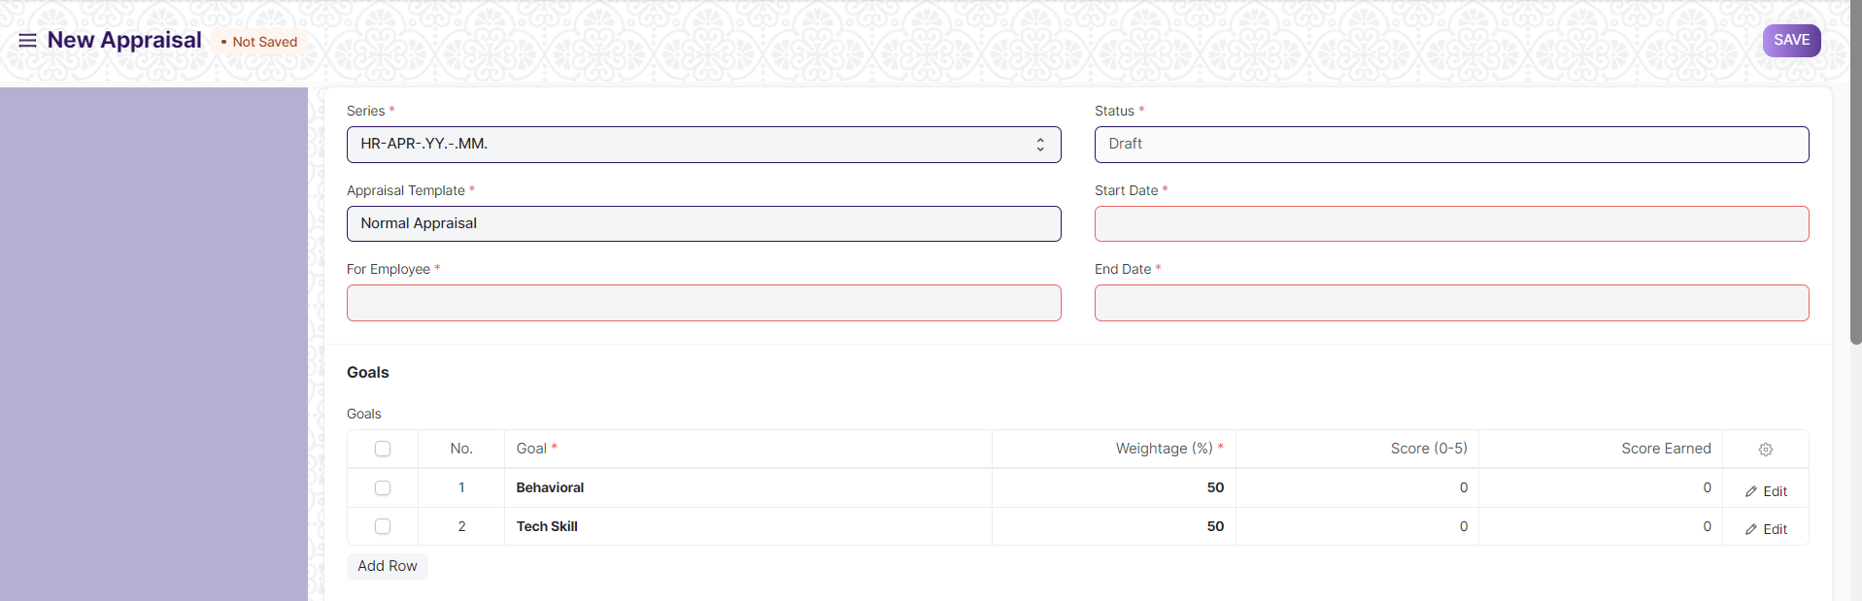

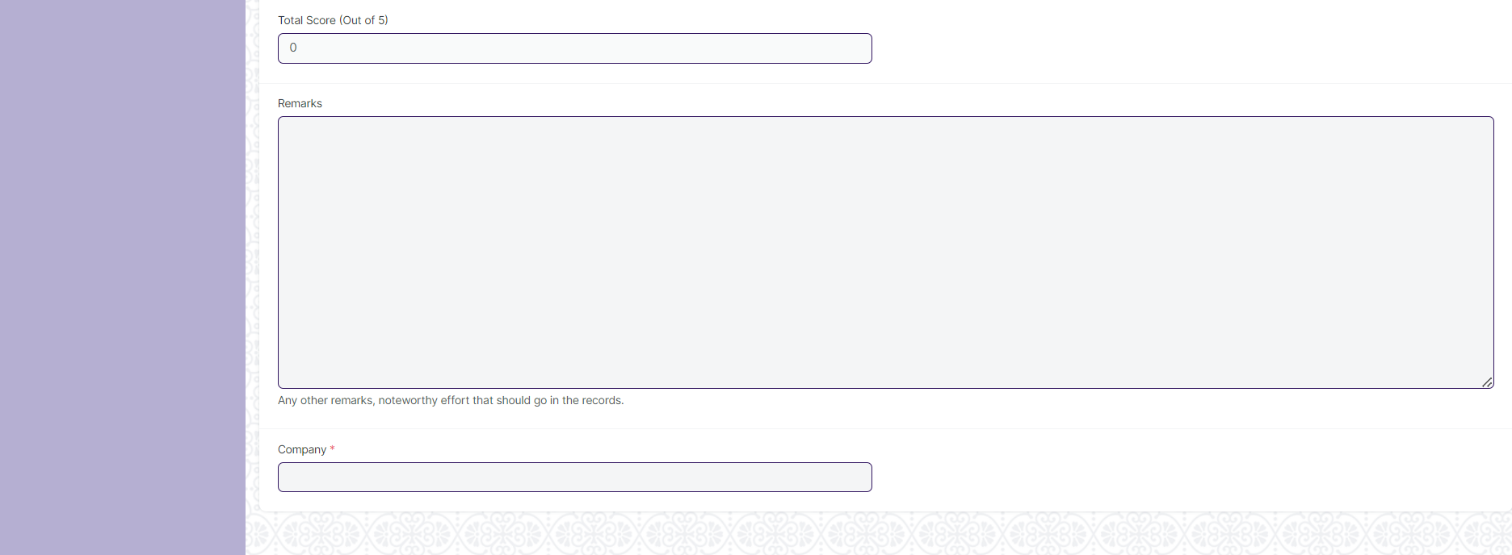

Figure 15 : Appraisal Screen

**Field List**

The following table describes the UI fields present in this screen :

|  |  |  |  |  |  |  |
| --- | --- | --- | --- | --- | --- | --- |
| **ID** | **Label** | **Type** | **Mandatory** | **Validation / Action** | **Remarks** | **R= Rename**  **N= New**  **D= Delete** |
| 1 | Series | Drop Down | Yes | User will select the naming series |  |  |
| 2 | Appraisal Template | Link | Yes | Link Field To the Appraisal Template Screen. |  |  |
| 3 | For Employee | Link | Yes | Link Field to the Master Screen Employee |  |  |
| 4 | For Employee Name | Text |  |  | Auto Fetched on selection of Employee |  |
| 5 | Status | Drop down | Yes | Options :  Draft  Submitted  Completed  Canceled |  |  |
| 6 | Start Date | Date | Yes | User will select Start date. |  |  |
| 7 | End Date | Date | Yes | User will select End date |  |  |
| 8 | Department | Link |  | Link Field to master screen Department |  |  |
| 9 | Goals | Table |  |  | The table is described below |  |
| 10 | Total Score | Number |  | All the scores in the Goals will be added and fetched . |  |  |
| 11 | Remarks | Text |  |  |  |  |
| 12 | Company | Link | Yes | Link Field to Company Screen |  |  |

|  |  |  |  |  |  |  |
| --- | --- | --- | --- | --- | --- | --- |
| **Appraisal Template Goals** | | | | | | |
| **ID** | **Label** | **Type** | **Mandatory** | **Validation/ Action** | **Remarks** | **R = Rename**  **N= New**  **D= Delete** |
| 1 | Goal | Small Text | Yes | User will set the KRA |  |  |
| 2 | Weightage | Number | Yes | User will set the weightage |  |  |
| 3 | Score | Number |  | User will give set the score for the particular goal between 0-5. |  |  |
| 4 | Score Earned | Number |  | Score Earned by the employee. |  |  |

**User: Roles & Permission**

The following table describes the users and their roles and permissions for the screens :

|  |  |  |  |  |  |  |  |  |  |
| --- | --- | --- | --- | --- | --- | --- | --- | --- | --- |
| **ID** | **Role** | **Select** | **Read** | **Write** | **Create** | **Delete** | **Submit** | **Cancel** | **Amend** |
| 1 | HR Admin/Director Admin | Yes | Yes | Yes | Yes | Yes | Yes | Yes | Yes |
| 2 | HR Manager/CS | No | Yes | Yes | Yes | No | Yes | Yes | No |
| 3 | HR Assistant | No | Yes | Yes | Yes | No | No | No | No |
| 4 | Employee | No | Yes | Yes | Yes | No | No | No | No |